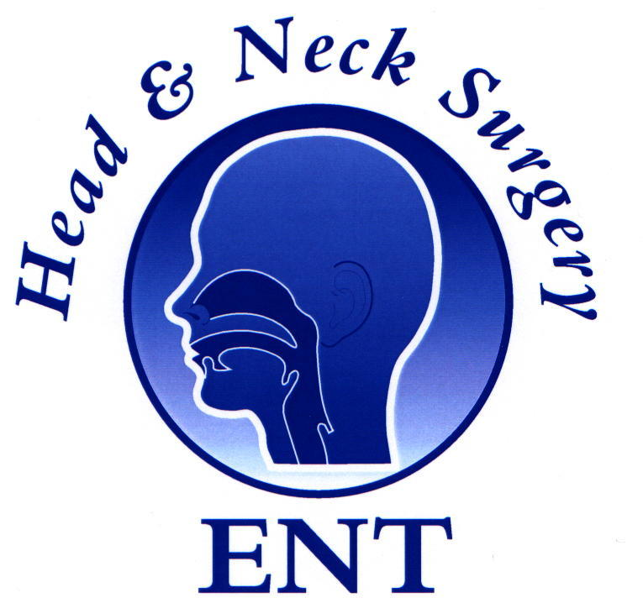
ENT MASTERCLASS ®

13th National ENT Radiology Masterclass

Virtual, Sunday, 26th June 2022,
Venue: The Education Centre,
Doncaster Royal Infirmary

Proposed Programme:

8:30 am Registration and Coffee

8:45 am Welcome: Chairman, Prof Jaydip Ray

Session I:

9:00 am Brief History of Imaging (20 mins)
Mr Jaydip Ray Link:
9:20 am Imaging for Parathyroid surgery (30 mins)
Mr M S Quraishi Link:
9:50am Role of Plain Film Radiology in ORL (30 mins)
Dr. Neelam Dugar Link:
10:20 am Imaging of the Skull Base: Anterior and Mid Base (30mins)
Dr Nigel Hoggard Link:
11:10 am MRI of the Head & Neck (40 mins)
Dr. Neelam Dugar Link:
11:50am The Posterior fossa & paragangliomas (30 mins)
Dr Nigel Hoggard Link:
12:40 Lunch

Session II

1:30 pm Nasal Imaging: The Surgeon’s Road Map (30 mins)
Mr Shaz Ahmed Link:
2:00 pm Ultrasound imaging in the Head & Neck (30mins)
Dr Ivor Waldron Link:
3:00 pm Sialograms & imaging of the mouth and mandible (30 mins)
Mr Amit Prasai Link:

3:30pm Question/Answers

3:45pm Close

