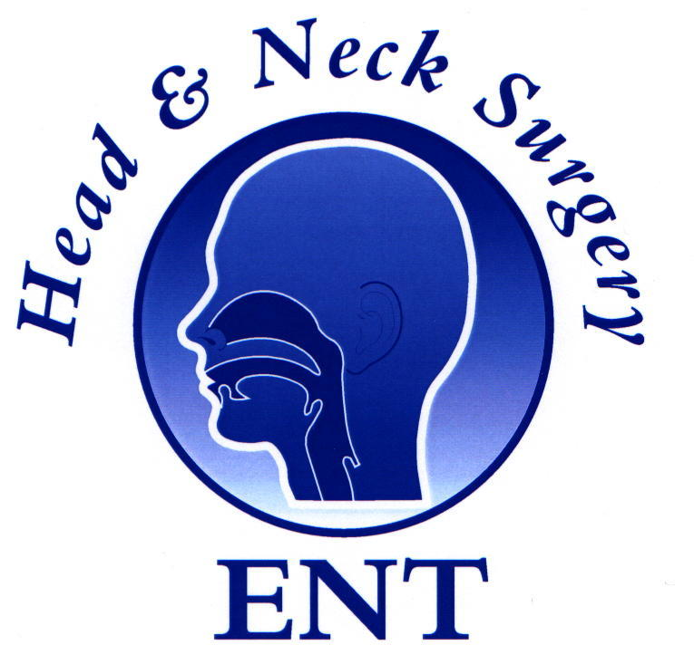
PROPOSED COURSE PROGRAMME (GMT TIME)
6th Annual National ENT Master Class® Doncaster 29th-31st Jan 2010

Friday 29th Jan 2010 (Day I, Paediatrics & Otology)

08:30 Registration

08:45 Welcome Mr Nigel Clifton OBE,
Chief Executive, Doncaster & Bassetlaw NHS Foundation Trust.

Session I (Paediatrics) Master Class lectures:

9:00 Mr. Haytham Kubba , ‘Paediatric Neck Lumps’

9:30 Mr. N. Bateman ‘The Paediatric Airway; pathology & reconstruction’ .

10:00 Mr. Haytham Kubba ‘Paediatric drooling, Evaluation and management’.

10:20 Tea & coffee

10:40 Prof. A. A. Narula ‘Paediatric hearing loss; Diagnosis & management’

11:20 Mr . D. Selvadurai ‘Sudden sensorineural hearing loss; Evaluation and
management’.

11:40 Mr. A Marshall ‘Cochlear implant surgery __why bilateral?’

12:10 Panel Discussion (Moderator: Prof A A Narula)

13:00 Lunch

Session II (Otology) Master Class Lectures:

13:40 ENT Masterclass Lecture: 2010
Mr. L Flood ‘Anatomy & Pathology of the Middle Ear’

14:20 Mr J Dugar, ‘Otosclerosis’.

14:40 Mr G. Reilly ‘The Dizzy patient’ (BPPV & Meniere’s)

15:10 Prof. S. Saeed ‘Master Class on the Facial nerve’

15:40 Tea & Coffee

15:50 Prof. S. Saeed, ‘Skull base lesions and management’.

16:20 Panel Discussion:
Moderator: Prof Shak Saeed

17:15 Guest lecture: Prof Narula:
‘Revalidation & Licence to practice’
17:45 Launch of Journal of ENT Masterclass 2009
Dr Emyr Jones, Medical Director, Doncaster & Bassetlaw NHS Foundation Trust.

19:00 Dinner (Curry night out at the Aagrah Restaurant, Doncaster)

Saturday 30th Jan 2009 (Day II, Rhinology and Allied Subjects)

Session I :- Rhinology Prof. N. S. Jones, Mr. D. W. Skinner, Mr. A. Sama,
Mr U Raghavan, Mr. H. Saleh,

9:00 Rhinitis and Rhinosinusitis- Classification and Diagnosis UR
9.15 Assessment in Septorhinoplasty UR
9.30 Granulomatous conditions of the nose NSJ
9.45 Tumours of the Nose and Paranasal Sinuses NSJ
10.00 Snoring and Obstructive Sleep Apnoea AS
10.15 Safety in Sinus Surgery AS

1030 Tea &Coffee

11.00 Evidence Based medical management of Chronic Rhinosinusitis
and Nasal Polyposis DWS
11.15 Management of acute complications of Sinus Disease DWS
11.30 Fungal Rhinosinusitis- classification and management HS
11.45 Structured approach to Paranasal sinus Radiology HS

12.00 Lunch

13.00 Facial Pain NSJ
13.15 DCR DWS
13.30 Local Flaps and principles UR
13.45 CSF leaks HS
14.00 Structured approach to Frontal Sinus Surgery AS

  - Case presentations/panel discussion NSJ/DWS/AS/UR/HS

15.15 Tea and Coffee

SESSION II

15:40 Dr. A. Verghese ‘MDT: The pathologist’

16:00 Dr. N. Dugar. ‘MDT: The Radiologist’.

16:20 Mr. D. Selvadurai. ‘Journal club; How to handle a paper?’

16:40 Session III (Clinical Grand Rounds)
Group A (Room A)
Group B (Room B)
Group C (Room C)

19:00 Course Dinner (Doncaster)

Sunday 31st Jan 2010 (Day III, Head & Neck Surgery)

Session I (Head & Neck Oncology)

09:00 ENT Masterclass Lecture, 2010:
Prof Patrick J Bradley. ‘The life of a Head & Neck Surgeon’.

09:30 Mr Charles Giddings (President AOT)
Exit exams: current news

09:45 Mr. N. P. Beasley ‘Decision making in Head and Neck Oncology.’

10:15 R Simo. Evaluation and management of Thyroid Nodules.

10:45 Mr. T. Westin ‘Head & Neck Reconstruction’

11:15 Mr. G. Perks ‘Principles of Axial and free flaps’

11:45 Coffee

12:00 Dr. A. Norris ‘The ENT Anaesthetist’

12:20 Dr. B. Foran ‘Chemo-Radiation in Head & Neck Cancer’

12:40 Mr. N. P. Beasley ‘Salivary Gland Neoplasms; Current opinions.’

13:00 Lunch

13:45 Mr A Jebreel, ‘Benign Head & Neck disease’.

14:00 Mr Paul Harkness, ‘Audit in Otolaryngology’.

14:20 Mr Martin Payne, ‘Interventional Techniques for Salivary Gland Calculi
and Strictures’.

14:40 Mr. M S Quraishi, ‘Minimal access Day case Parathyroid surgery’.

15:00 Panel Discussions (Moderator: Mr. Nigel Beasley)

16:20 Tea Coffee

16:40 Clinical Grand Rounds
Close

