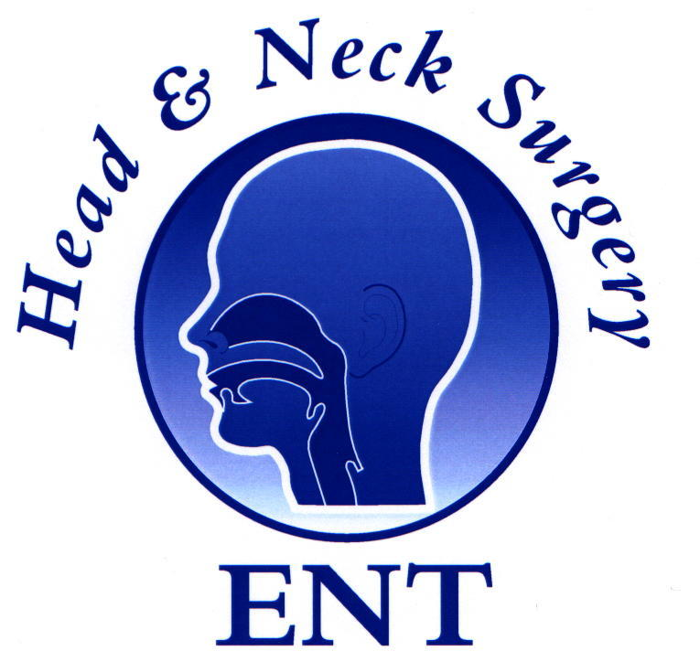

ENT Masterclass® Gold Medal 2015

The 11th ENT Masterclass will be held at the Royal College of Surgeon’s London.

The ENT Masterclass® training platform continues to provide free training for hundreds of trainees and nurses every year. We have 9 courses as well as an Annual Journal and a 3-day WEBCAST. With the support of the faculty and the Masterclass team we have strived to provide high quality training ‘free at the point of delivery’!

We are now pleased to announce that at the 11th National ENT Masterclass (23rd-25th Jan 2015), there will be a Trainee’s Paper Section. A panel of judges will choose the best presentation and the winner will be awarded the:

ENT Masterclass® Gold Medal, 2015.
The Abstracts shall be published in the following year’s Journal of ENT Masterclass.

An accepted paper guarantees you a place in the course!

Abstract submission guidelines:
- Applicants must be in training grades in the United Kingdom.
- The paper should not have been published or presented at a national or international meeting previously.
- Presentations will be for 8 minutes followed by 2 minutes for discussion.
- Abstracts must be structured, with a maximum word count of 250 words and submitted electronically.
- The presenting author’s full details including name, work address, e-mail address and name of institution where the work took place must be given.
- All submissions should contain a statement of copyright permission and that all authors have agreed the contents of the paper for submission.
- Abstracts should be submitted to entmasterclass@hotmail.com

